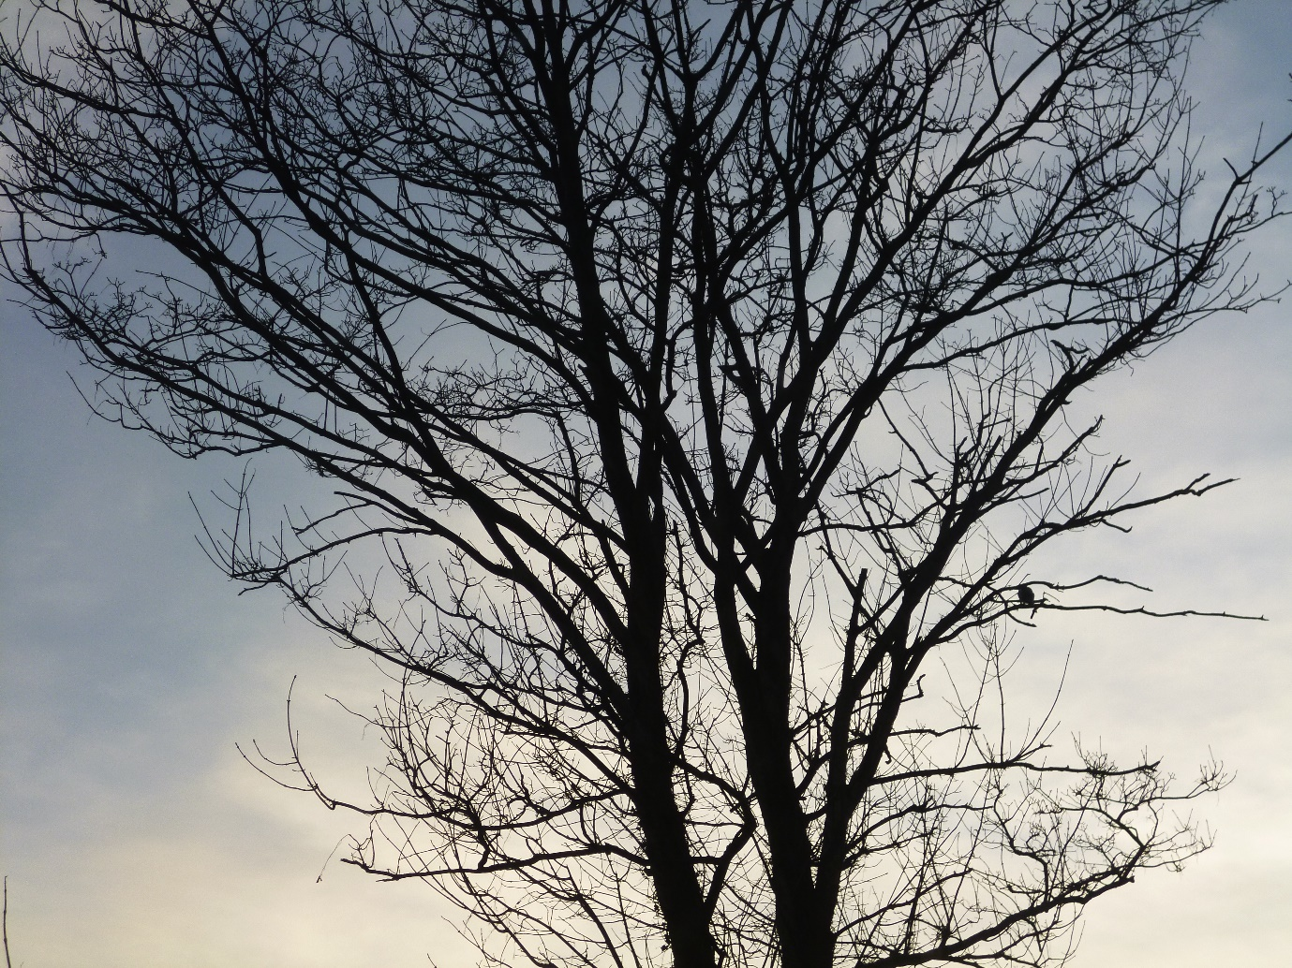

Solstice

Winter afternoon
tree silhouettes
exposed
against stone-washed skies
their bronchiole black fringe
catching pink breath.

John Irving Clarke

